AUSTRALIAN COUNCIL FOR THE DEFENCE OF GOVERNMENT SCHOOLS

PRESS RELEASE 549#

TONY ABBOTT ATTACKS STRUGGLING PARENTS AS WELL AS

DISADVANTAGED CHILDREN

19 April 2014

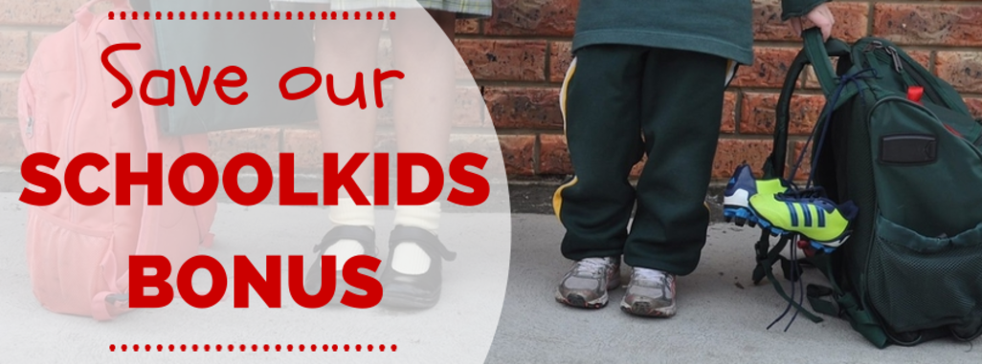

A group of parents have woken up to the simple fact that Mr Abbott and his Treasurer have no intention of sharing the budget pain around. The major burdens will not fall upon multinational corporations buying up Australia’s wealth while minimising tax; wealthy church organisations that enjoy tax exemptions; or wealthy individuals that get tax breaks for educating their children in private schools.
No, the burden will fall upon parents with children in public schools.
A group of parents have woken up to what is happening. Join them in their petition at http://saveourschoolkidsbonus.nationbuilder.com/?recruiter_id=834

JOIN THE CAMPAIGN TO SAVE THE SCHOOL KIDS BONUS
Prime Minister Tony Abbott wants to take the SchoolKids Bonus payment away from families.
The SchoolKids Bonus is an annual payment of $410 for primary school children and $820 for secondary school children made in two instalments in January and July.
More than 35,000 eligible Tasmanian families are at risk of losing the SchoolKids Bonus if the Abbott Government tears up the legislation.
This is a savage cut to families from a Government that doesn’t care about helping kids get a great education.
Sign the petition below to help send Tony Abbott a message that the SchoolKids Bonus must be spared from his cuts.
373 SIGNATURES
1,000 signatures
Top of Form

Thank you for signing!
Remove signature
Bottom of Form
Like this to spread the word:

